Christopher Spencer  
Course: CYB 220-11252-M01 Network Security

Matthew Fouquier

November 28, 2025

CYB 220 Project One – Virtual Systems & Networking Concept Brief Outline

## I. Introduction

This concept brief outlines the configuration of virtual systems and network resources within a sandboxed environment to support secure testing and analysis. As a security analyst, I used the GNS3 virtualized lab environment to implement required group policy changes, create user accounts, and configure IP addressing across multiple machines. Sandboxing allows these settings to be tested without risking the stability of a live production network, making it an essential method for evaluating system behavior and validating security changes. The following sections document each configuration completed in the virtual environment and provide an explanation of the broader benefits, limitations, and uses of virtualization technology.

## II. Using Virtual Systems

This section reviews the Windows Group Policy configurations and the network configurations applied as part of Project One Activity.

## A. Group Policy Configuration

The following Local Group Policy changes were made on PC1_Admin as required:  
- Interactive logon message text  
- Minimum password length set to 8  
- Prevent changing desktop background  
- Audit logon events enabled  
- Force specific logon screen image  
- Windows Firewall: Set inbound/outbound connections to allow  
  
Screenshot evidence will be included in the screenshots section.

## B. Network Resource Configuration

Network settings such as IP address, subnet mask, default gateway, and DNS settings were configured to match the requirements in the scenario. Screenshots will be attached in the final section.

## III. Conceptual Justification for Virtualization

This section explains the benefits and drawbacks of virtualization and provides an additional real-world use case.

## A. Benefits of Virtualization in Sandboxing

## Virtualization provides several important benefits when creating a sandboxed environment. First, it allows organizations to safely test system configurations, group policy changes, and network settings without risking the stability of production systems. Because each virtual machine operates independently, analysts can experiment, revert snapshots, and intentionally break configurations without causing lasting damage. Virtualization also improves efficiency by reducing the need for physical hardware; multiple test systems can run simultaneously on a single host machine. Finally, sandboxing with virtual machines supports faster iteration, easier troubleshooting, and the ability to reproduce issues in a controlled environment, which strengthens the organization’s security posture.

## B. Drawbacks of Virtualization in Sandboxing

## Although virtualization has many advantages, there are also drawbacks to consider when using sandbox environments. Virtual machines depend heavily on the host’s hardware resources, which can cause performance issues if CPU, RAM, or storage are limited. This can lead to slower system responsiveness compared to testing real hardware. Additionally, virtual environments do not always perfectly mimic physical infrastructure, meaning some hardware-specific issues or network behaviors may not appear during testing. Virtualization platforms also require ongoing maintenance, patching, and configuration. If a sandbox environment is misconfigured or vulnerable, attackers could potentially escape the VM or exploit the host system.

## C. Additional Use Case for Virtualization

## Virtualization is also highly valuable for disaster recovery and business continuity. Organizations can create full virtual machine backups that replicate critical servers and services. In the event of hardware failure, corruption, or a cyber incident such as ransomware, virtualized systems can be restored quickly on alternate hardware or in the cloud. This dramatically reduces downtime and allows normal operations to resume without needing to rebuild physical servers.

## IV. Conclusion

## Completing this project demonstrated how virtualization and sandboxing provide a safe, flexible, and efficient way to test system and network configurations. By applying group policy changes, configuring network settings, and validating connectivity in a controlled environment, potential issues can be identified before changes are implemented in production. Although virtual environments have limitations such as performance constraints and imperfect replication of physical hardware, the advantages outweigh the drawbacks for most testing and security workflows. Overall, virtualization is a powerful tool that enhances system reliability, strengthens security procedures, and supports effective network management.

## V. Screenshots

1. GPO: Interactive logon message text

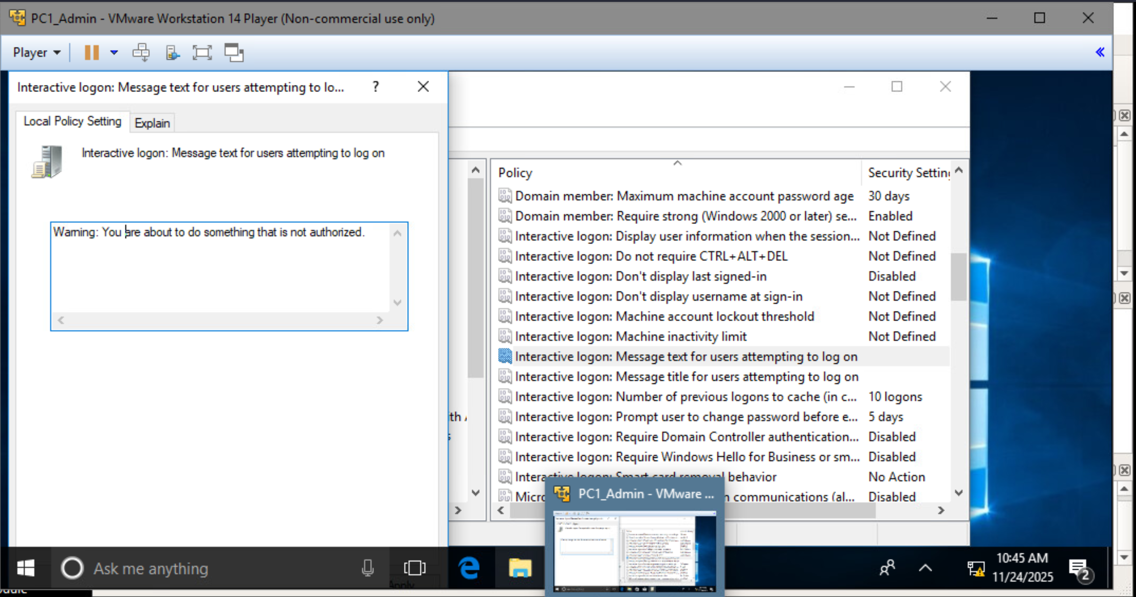

2. Minimum password length

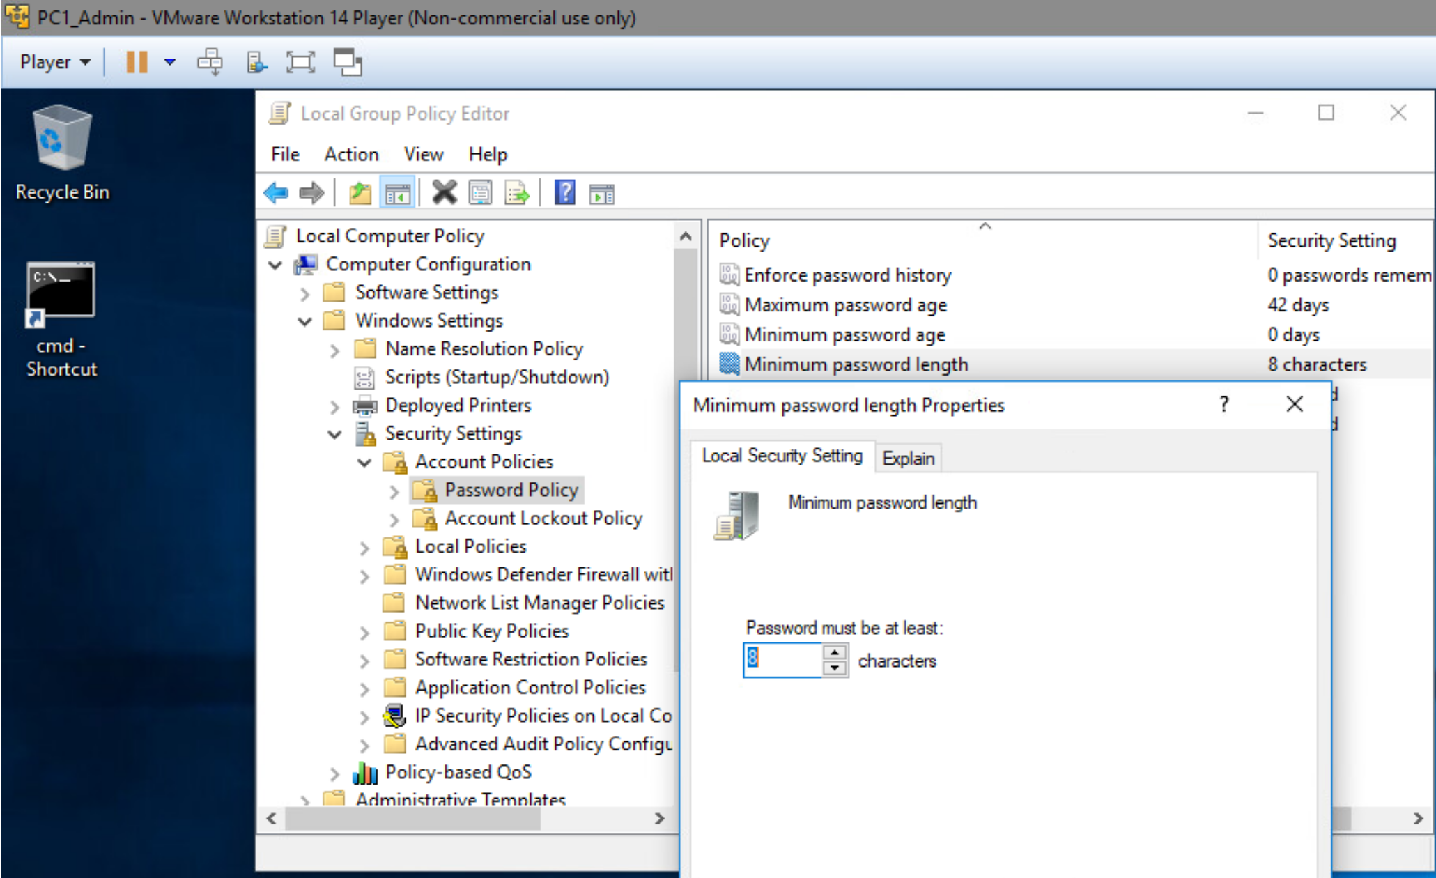

3. Prevent changing desktop background.

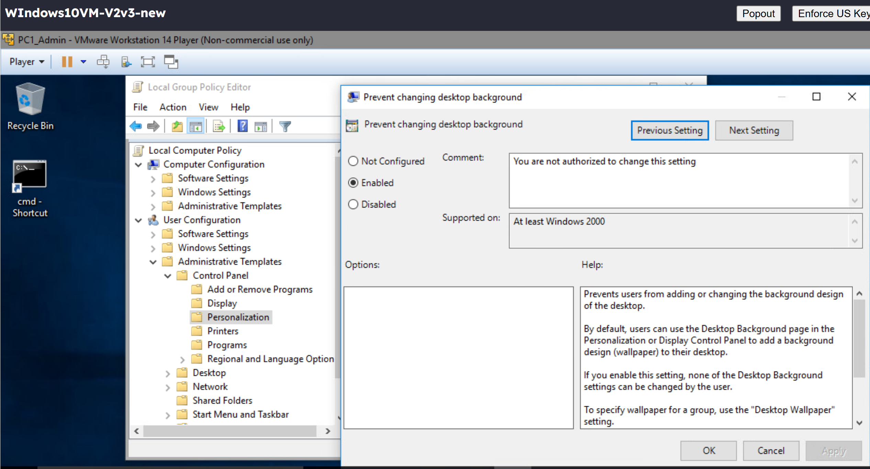  
4. Audit logon events

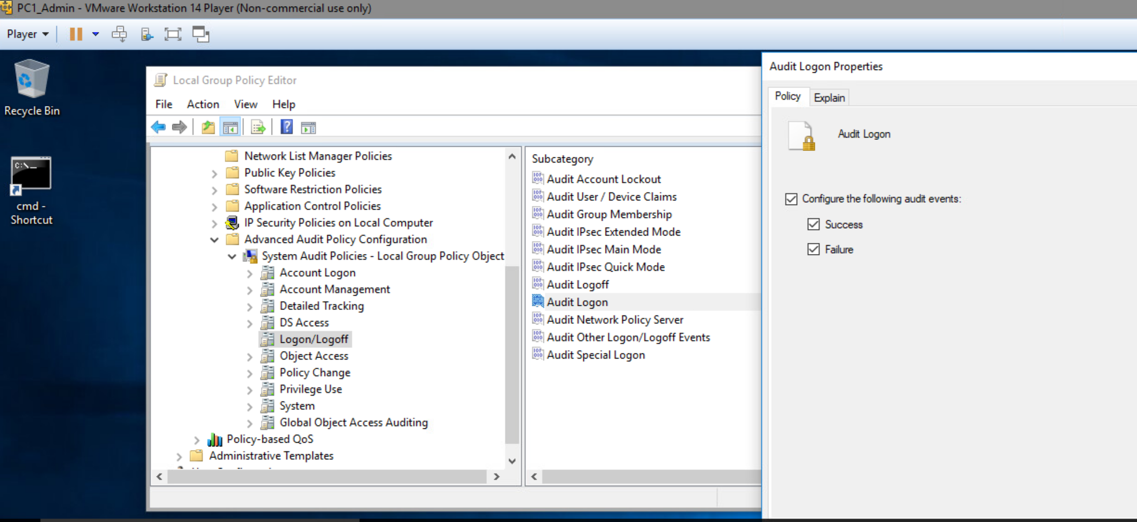

5. Forced logon screen image

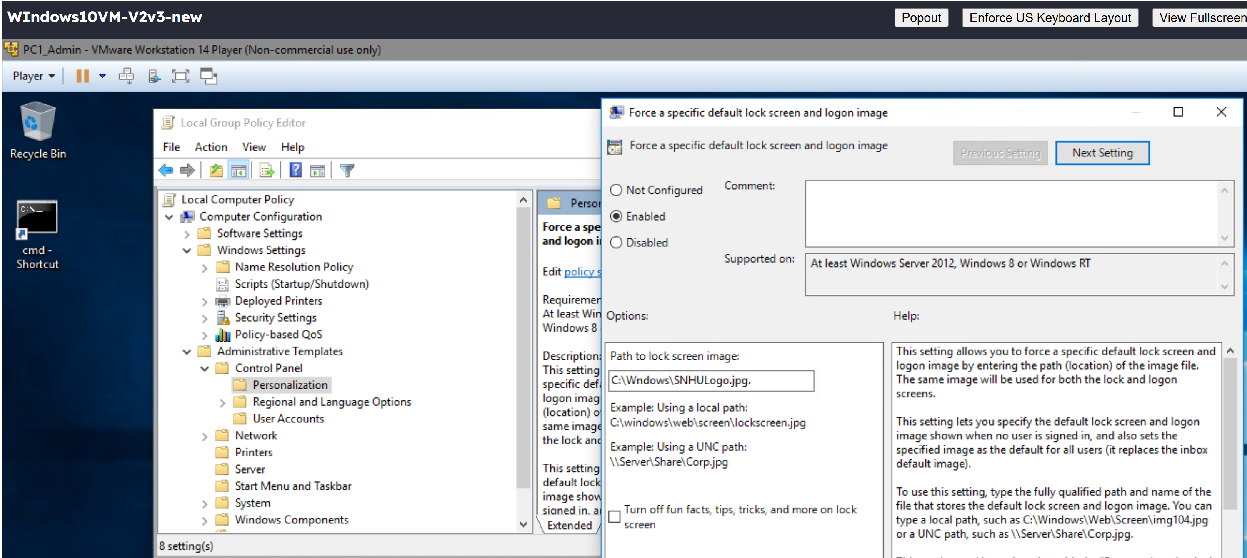  
6. Firewall configuration

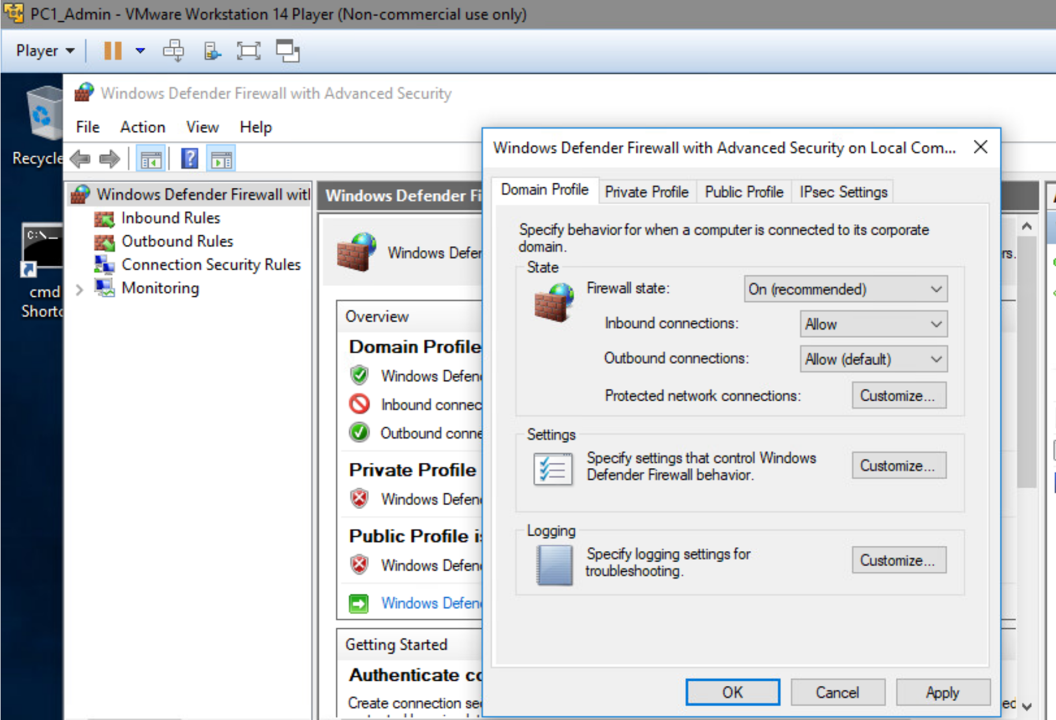

**B. Network Resource Configuration Screenshots**

1. PC1_Admin Network Settings

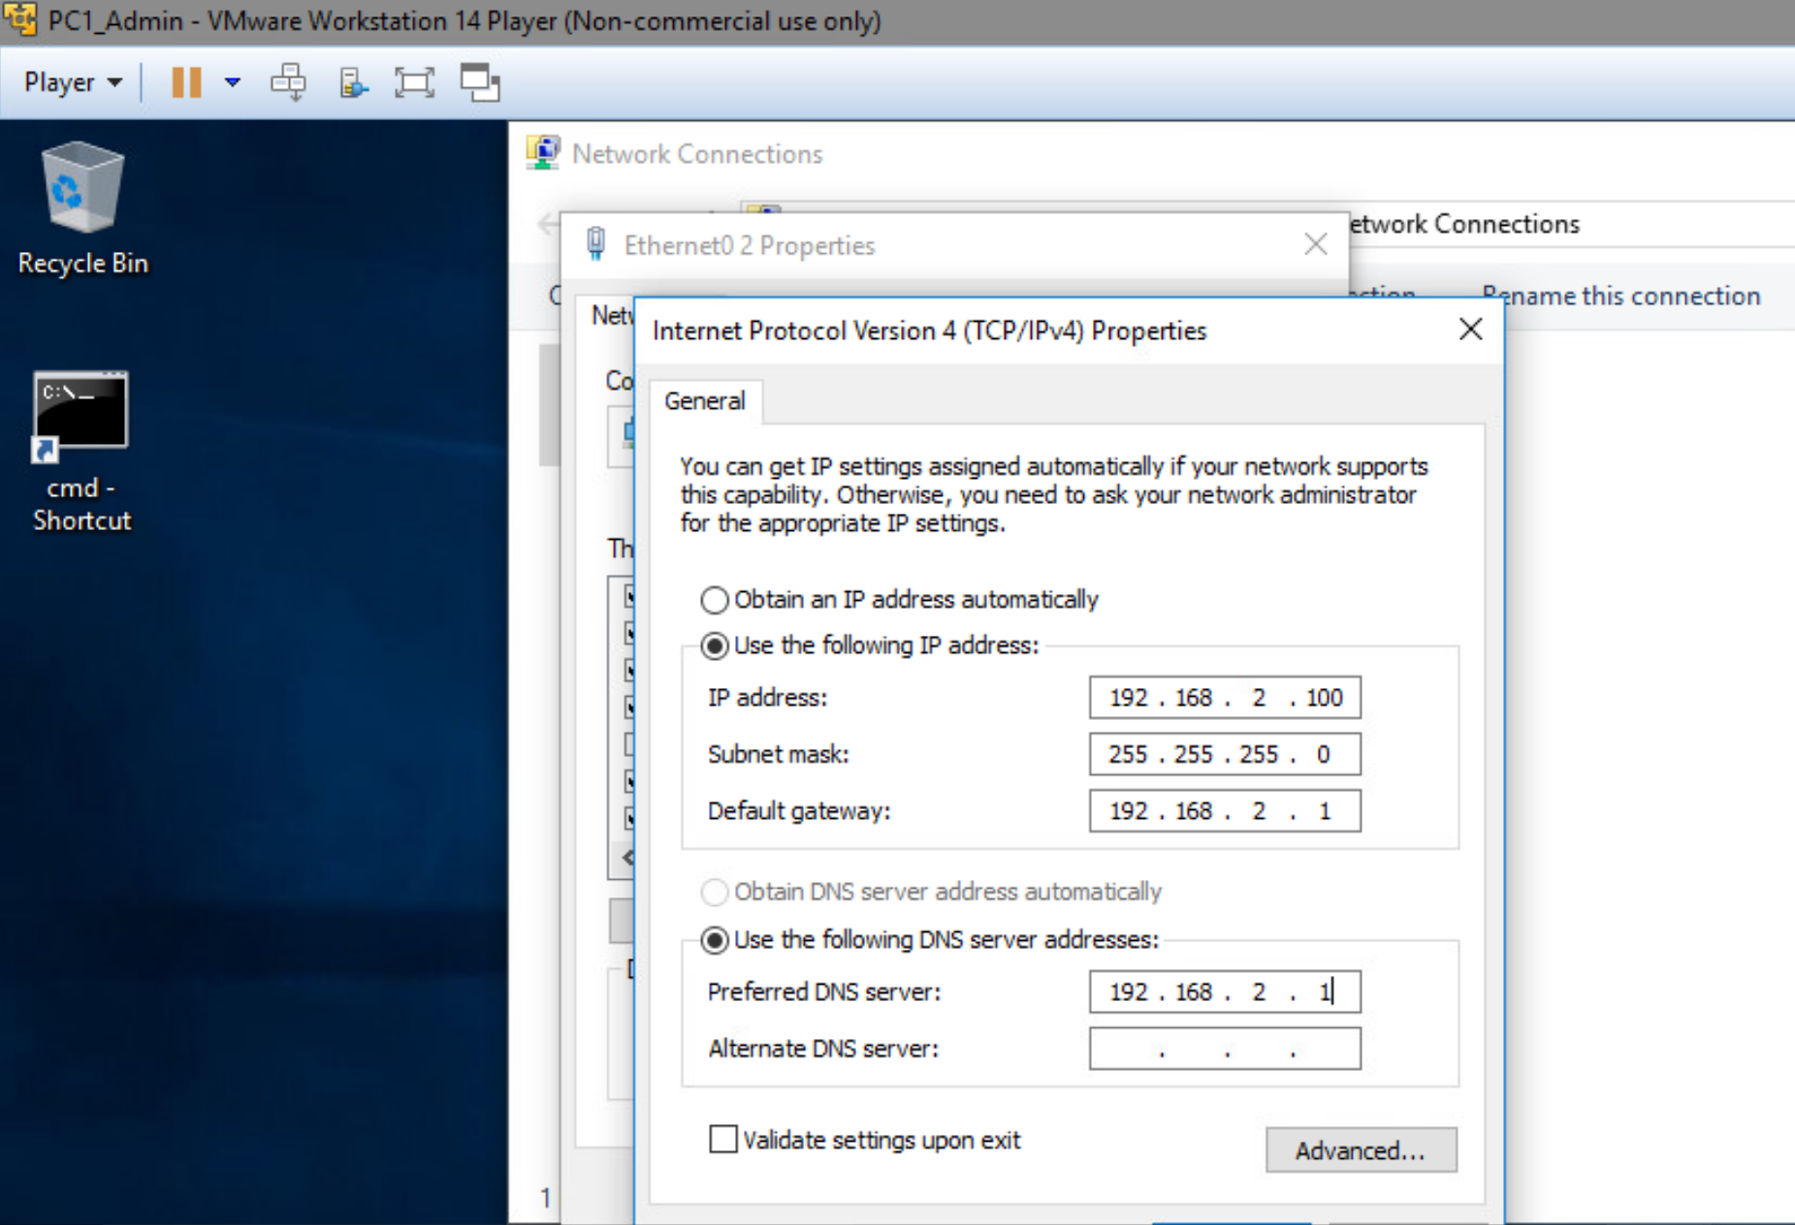

2. PC1_Kiosk Network Settings

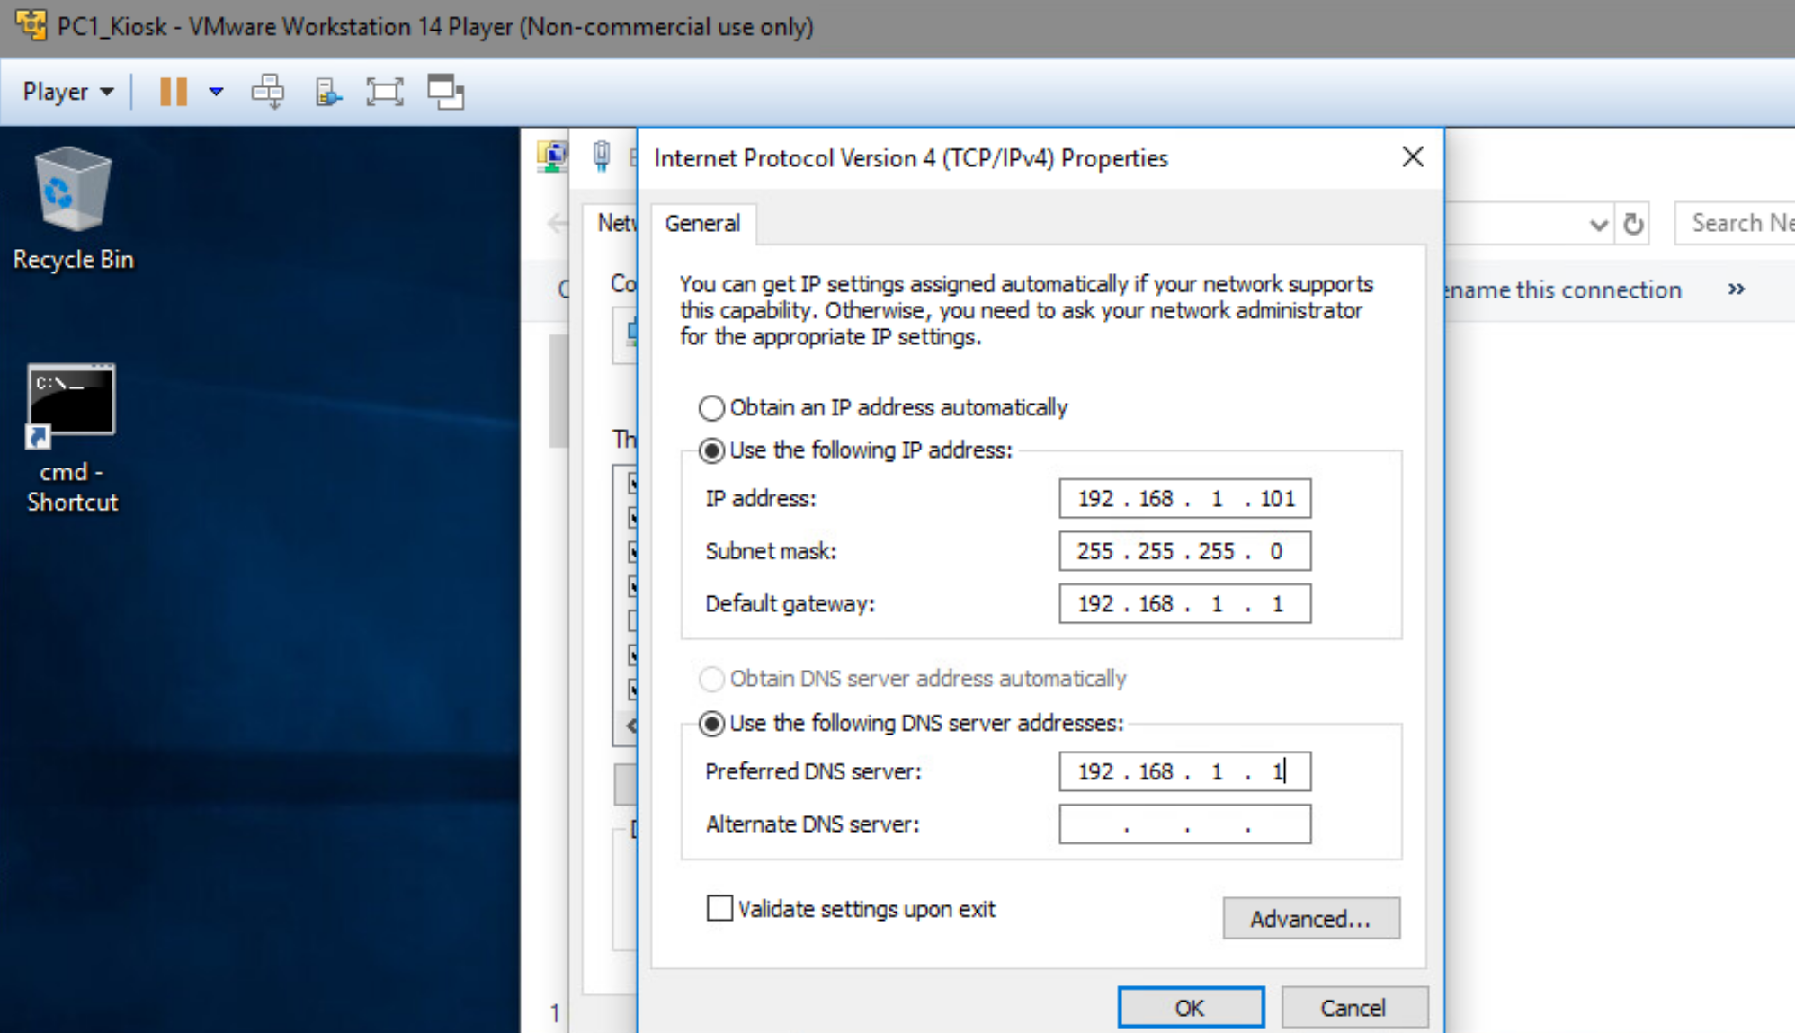

3. PC2_Kiosk Network Settings

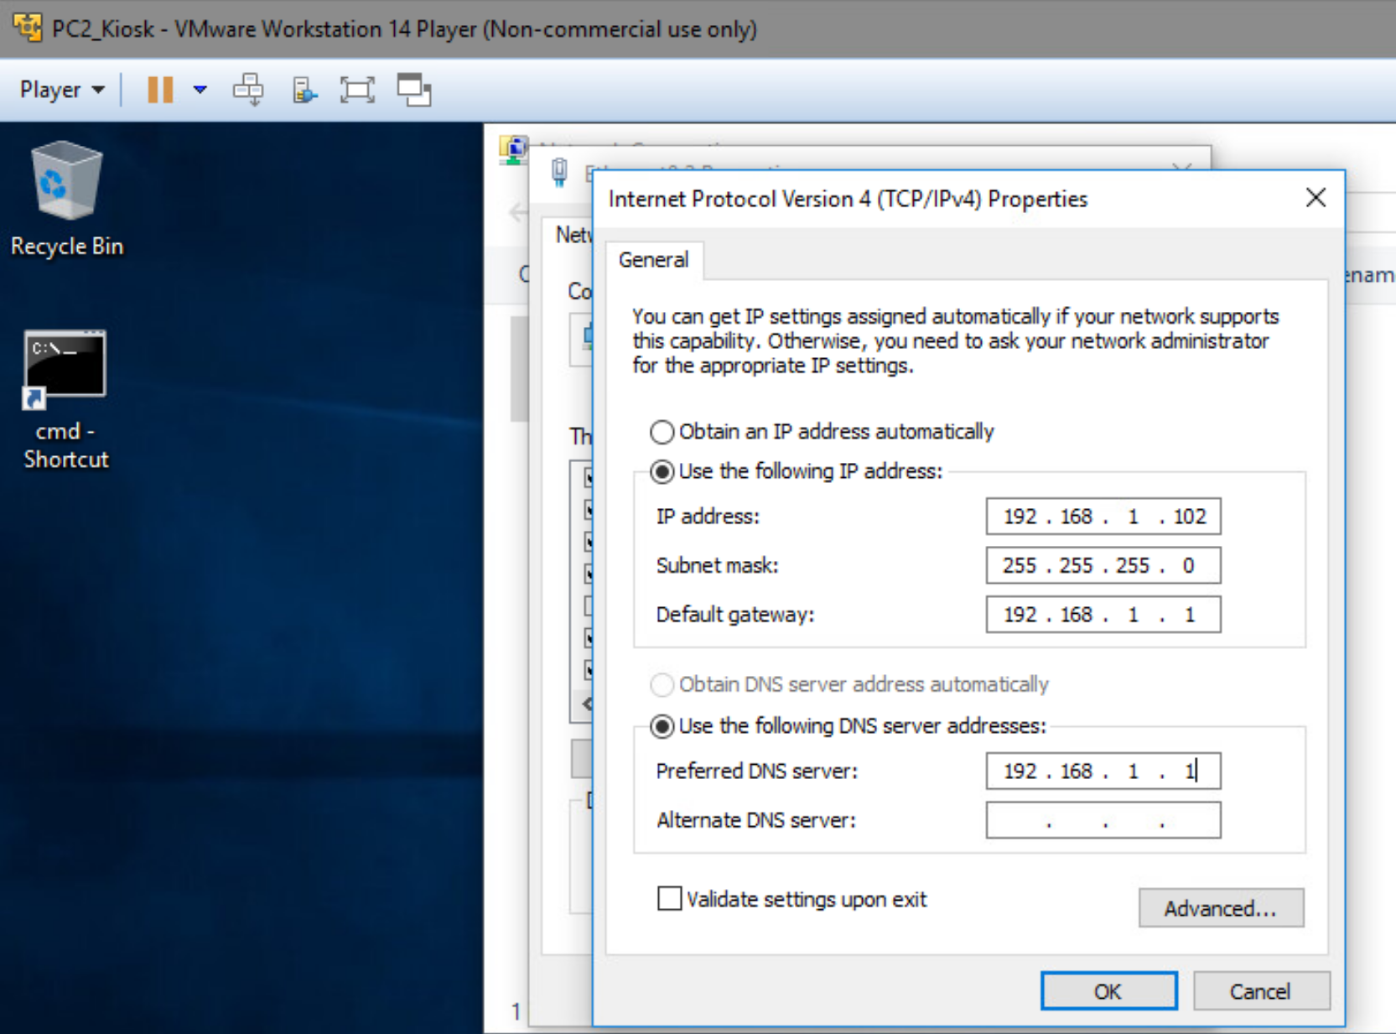

4. PC3_Kiosk Network Settings

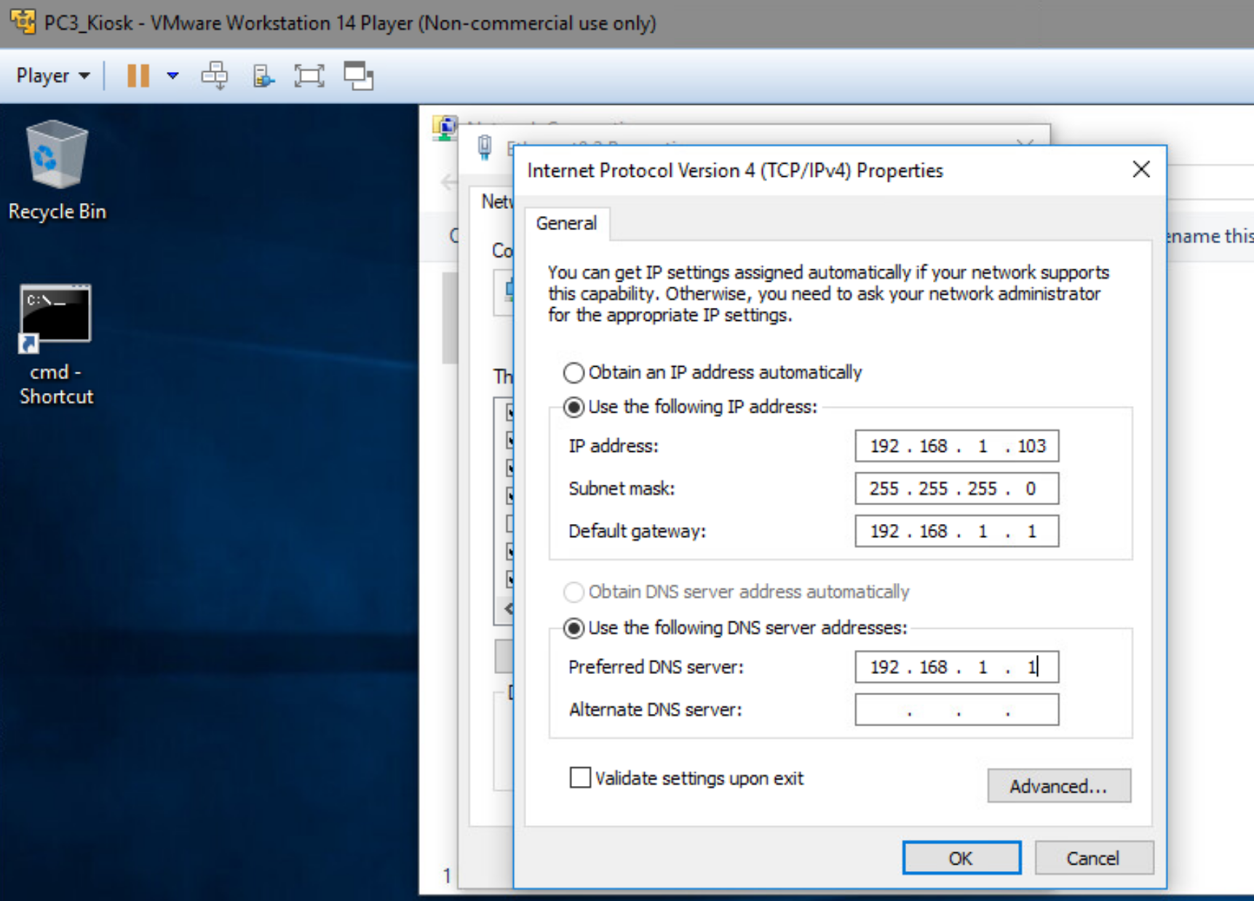

5. Server_Domain Network Settings  
